Magnetic loop antenna ver. 3

Assembly
a. The big loop (top and bottom)
b. The capacitor and motor assembly
c. The small loop

a. The big loop
1. Insert the 3d part nr 5 to the bottom of the loop.
2. Use a hot air blower or a strong soldering gun to take off 2cm of the plastic cover from both side of the loop.
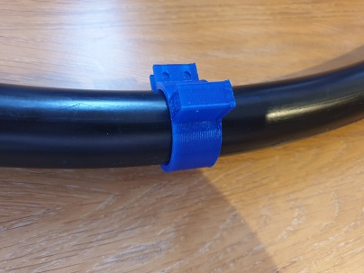
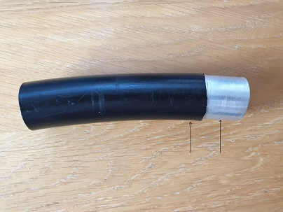
3. Insert the 3d part nr 1 to each side.
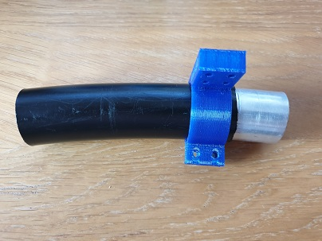
4. Insert the 3d part nr 3 into the big loop (x2) - with a small hammer.
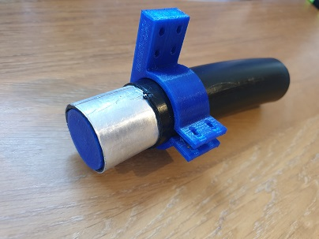

5. Wrap the aluminium with screen wire and tighten it with a clamp. (Both sides)
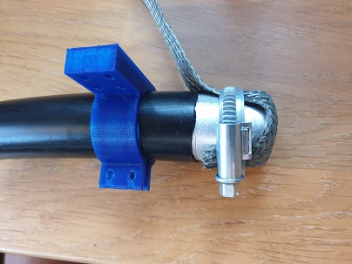
6. Connect the 2 sides top of the loop to the top bar holder (3d part nr 2)
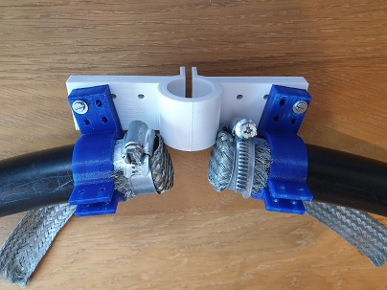

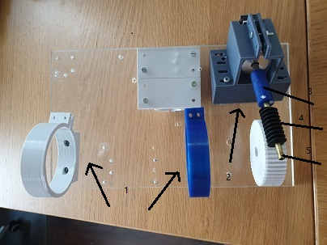
The capacitor and motor assembly. (On the plate)
All parts have to be put so the motor warm will be in good place with the gear.
1. Install 2 Vacuum holders (3 d part nr 12)
2. Install the step holder (3d part nr 11)
3. Install the shaft on the step motor (3d part nr 14)
4 Install the 4 mm X 3 cm long brass tube into the Worm Gear.
5. Install the brass into the shaft.

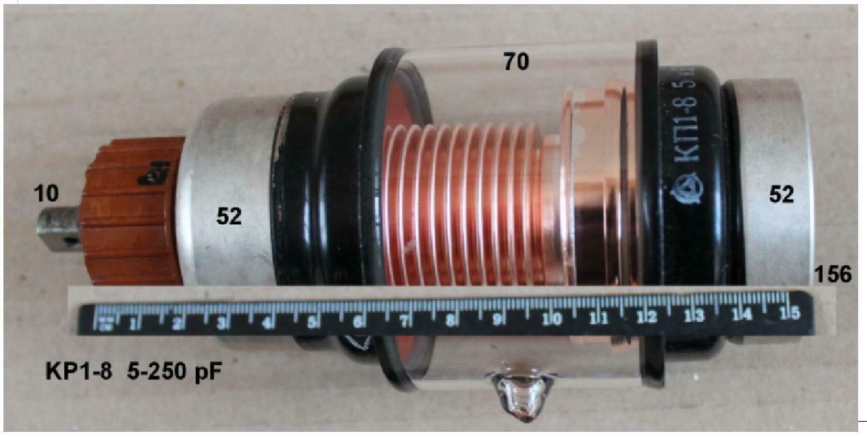
5. Install 2 mast plate holders (3d part nr 4)
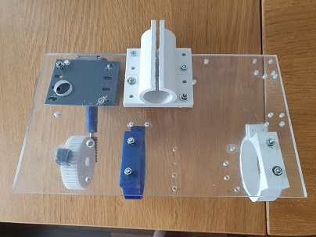

6. Put some grease in the gear and the warm.

The small loop.
1. Cut 65 cm of rg240 coax. (20% of the big loop)
2. Insert the 3d part nr 9 to the coax.
3. Take out 2cm of the plastic cover from both edges.
4. Install the bnc connector in the 3d part nr 7.
5. Solder both inner and outer of the coax to the bnc connector.
6. Connect the 3d part nr 10 to the 3d part nr 9.
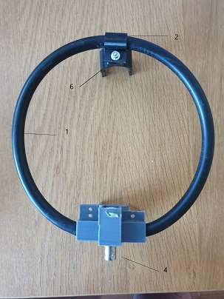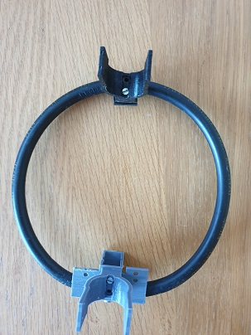
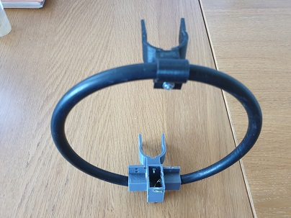
Final assembly
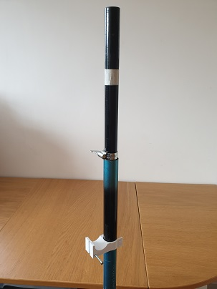
1 Install the 3d part nr 6 on the bottom of the mast (1 meter from the floor)
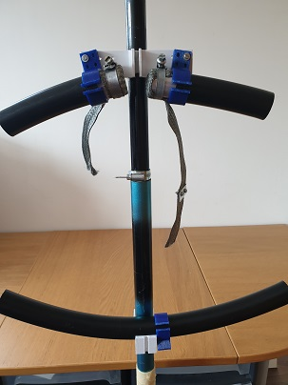
2. Install the big loop assembly on the top of the mast.
3. Install the motor/ capacitor assembly on top of the mast (opposite the loop assembly)
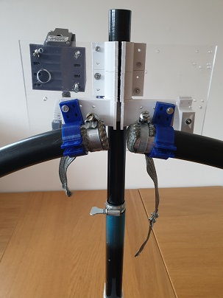
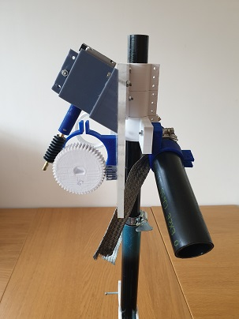
4. Install the small loop on the bottom of the mast inside the big loop.

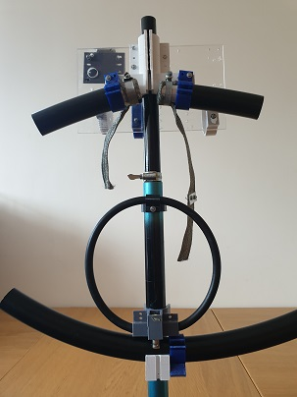

5. Connect the sleeve from the capacitor to the loop.

